Brainworks World Website Analysis

1. Not every page should require visibility and hover up when that part of the page is visible. It is a good idea for styling the website, but the content takes time to appear and doesn’t show up until the user actually scrolls down.
2. For the Insights Page, a scrollbar for the post can be styled accordingly to make it look more professional.
3. On the Career Page and About pages, the images for people can be optimized and made to appropriate sizes on Large screen devices. (The images pop up way too big)
4. Working Social Links in the footer can be updated.
5. Individual pages can have their own meta descriptions, included with the Open Graph/ Facebook meta tags and the Twitter Meta tags to help give more information when the website is shared with others or on Twitter.



No popups appear when being shared with Whatsapp (Opengraph meta tags take care of it)

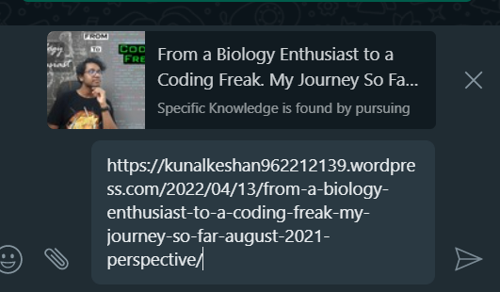

When Opengraph meta tags are present, It will show a popup like this!

1. Copyright information needs to be updated at the footer of the website.



1. Email links can have a href of mailto:<email address>, it will increase user experience when the want to send emails.

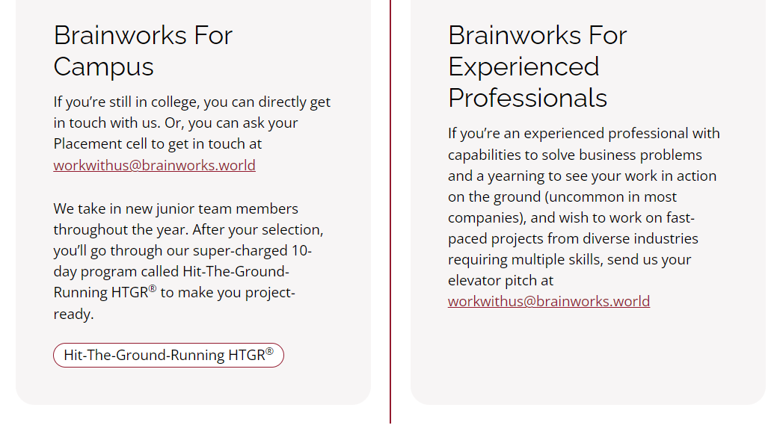

1. For the people section in the about page, social links can be added for each person to easily navigate to that individuals profile.